**Task 5 Report**

**1. Add Task Description**

The **React Todo List App with Counter** is a simple application that allows users to:

* Increment a counter in the parent component.
* Manage a to-do list in the child component. Users can add new tasks, and the tasks are displayed in a list dynamically.  
  The application uses useMemo to optimize performance by preventing unnecessary re-renders of the child component.

**2. Output**

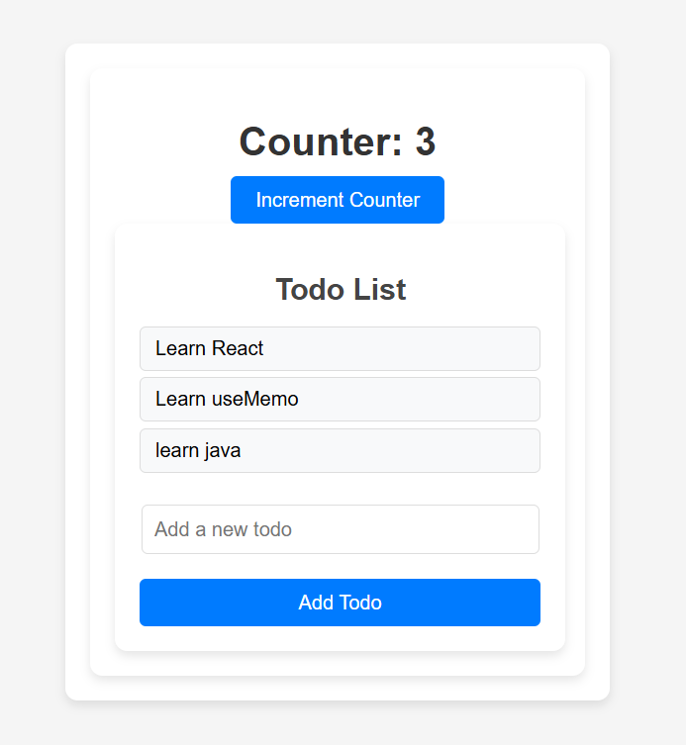

**3. Describe Widget/Algorithm Used in Task**

**Widgets/Components Used**

1. **Parent Component**:
   * Displays a counter and an increment button.
   * Utilizes useMemo to prevent re-renders of the child component unless the todos prop changes.
2. **Child Component**:
   * Manages the to-do list.
   * Accepts new tasks via an input field and displays the updated list dynamically.
   * Uses React.memo to avoid re-renders unless its props (todos and addTodo) change.

**Algorithm**

1. **Counter Increment**:
   * A simple useState hook is used to maintain the counter.
   * Updates only the counter value without affecting the child component.
2. **Todo List Management**:
   * Uses useState to store and update the to-do list.
   * New tasks are added to the array using the addTodo function passed from the parent component.
   * Updates are displayed in real-time via React's state reactivity.
3. **Performance Optimization**:
   * useMemo is used in the parent to memoize the child component.
   * React.memo in the child prevents unnecessary updates unless the todos prop changes.